- In this demonstration we will look at machining a 3D part in ArtCAM Insignia and ArtCAM Express. We will start by simulating the pre-created toolpath so we can see the finished design, then we will create our own toolpaths on the model.

3D Crest Machining


- Click on Open Model select Crest.art
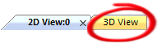
- Click on the 3D View Tab found in the top left corner to switch to the 3D view.
- From the project panel select the Toolpaths section.
- Under this are pre-created toolpaths which can be seen by clicking the plus sign next to the toolpath heading, these are the toolpaths that we will now simulate to view the finished piece.
- Right click on the Toolpaths section and select Simulate all Toolpaths
- ArtCAM Insignia gives you the option to change the resolution of the simulation so you can view the finished piece more clearly, ArtCAM Express has a fixed resolution.
- In ArtCAM Insignia select Simulate Toolpath (ArtCAM Express will do this automatically).

Creating the toolpaths
- The next steps will be creating the toolpaths over the design and saving them out to a machine, but firstly we will delete the previously created ones.
- Under the toolpath section on project panel, select the individual toolpath, right click and select the Delete Toolpath until both toolpaths are deleted.
- Select the Delete Simulation from the right click menu of Toolpath section.
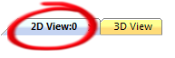
- The model will now consist of a 3D relief and a couple of vectors which are ready for the toolpaths to be created on.
- Click on the 2D view tab to view the artwork for the design.
- Select the rectangular vector.
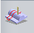
- From the 3D Toolpaths section located in the lower half of the project panel select the Machine Relief function.
- Use the following values:
- Area to Machine – Selected Vector
- Inside Vector
- To define the Finishing Tool click on Click to select… for Finishing options
- From Metric Tools
- Wood or Plastic
- 3D Finishing
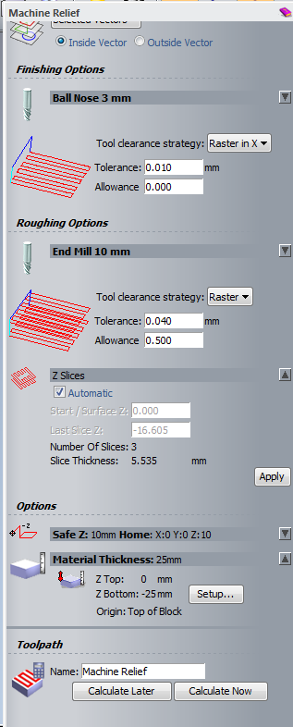
- Select Ball Nose 3mm
- To define the Roughing Tool click on Click to select… for Roughing options
- From Metric Tools
- Wood or Plastic
- Roughing and 2D Finishing
- Select End Mill 10mm
- Check - Z Slices - Automatic
- Material Thickness - Setup
- Material Thickness –25mm
- Model Z Zero – Top
- Model Position in Material – Top
- Click on Calculate Now
- Click on the X to close the toolpath panel
- Click on the 3D view tab.

- From the projects panel select the Toolpaths section.
- Under this the calculated Machine Relief toolpaths will be populated, this is the toolpath that we will now simulate to view the finished piece.
- Right click on the Toolpaths section and select Simulate all Toolpaths
- In ArtCAM Insignia select Simulate Toolpath (ArtCAM Express will do this automatically).
- ArtCAM Insignia gives you the option to change the resolution of the simulation so you can view the finished piece more clearly, ArtCAM Express has a fixed resolution.

Saving the toolpath

- Select Toolpaths section from the Project panel to view all the toolpath creation function
- From the Toolpath Operations located in the lower half of the project panel select the Save Toolpaths function to open the Save Toolpaths box.
- Using the top arrow move the Roughing Toolpath into the right hand column if it not already present on the right hand side.
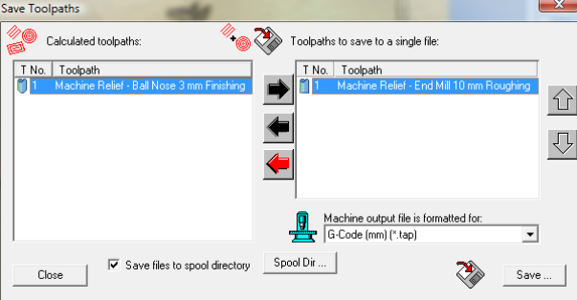
- From the Machine Output File is Formatted For: box, select your machine from the pulldown menu and click Save.
- In the File Name: section type Crest Roughing and click Save to save your toolpath ready to load onto your machine.
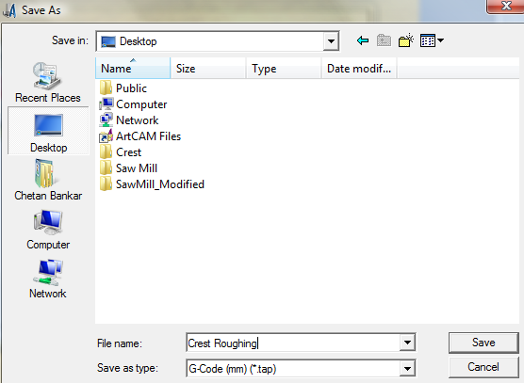
- Using the arrow buttons move the Finishing toolpath into the right hand column and the Roughing toolpath back to the left hand panel.
- From the Machine Output File is Formatted For: box, select your machine from the pulldown menu and select Save.
- In the File Name: section type Crest Finishing and select Save to save your toolpath ready to load onto your machine.

