- In this demonstration we will look at V-Bit carving a complex pattern, this can be done in ArtCAM Insignia and ArtCAM Express. We will start with simulating the pre-created toolpath so we can see the finished design, then we will create our own toolpath on the model.

V-Bit Carved Pattern

- Click on Open Model and select Pattern Model. art.
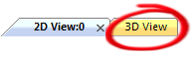
- Click on the 3D View Tab found in the top left corner to switch to the 3D view.

- On the Project panel, click on plus sign next to the Toolpaths section to highlighted the pre-created toolpath [V-Bit Carving], this is the toolpath that we will now simulate to view the finished piece.
- Right click on the V-Bit toolpath and select Simulate toolpath.
- ArtCAM Insignia gives you the option to change the resolution of the simulation so you can view the finished piece more clearly, ArtCAM Express has a fixed resolution.
- In ArtCAM Insignia select Simulate Toolpath (ArtCAM Express will do this automatically).

- Click on the 3D Graphics Option icon on the 3D View toolbar and under the Simulation Rendering select the wooden textures as a material to view the piece as it would look if cut in wood off a machine.
- Click on Apply and then close
- The next steps will be creating the V-Bit toolpath over the design and saving the toolpaths out to a machine. Before that we will delete the existing toolpath
- Right click on the V- Bit Carving toolpath on the Project panel and select Delete. Press Yes to confirm the delete.
- Right click on the toolpaths and select Delete Simulation.
- The model will now consist of vector artwork ready to have a toolpath created.
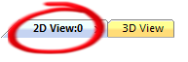
- Click on the 2D view tab to view the artwork for the design.

- Using the left mouse button drag a large box around all of the artwork to select all the vector lines.
- On the Project Panel click on V-bit Carving toolpath function located in the lower half of the panel.
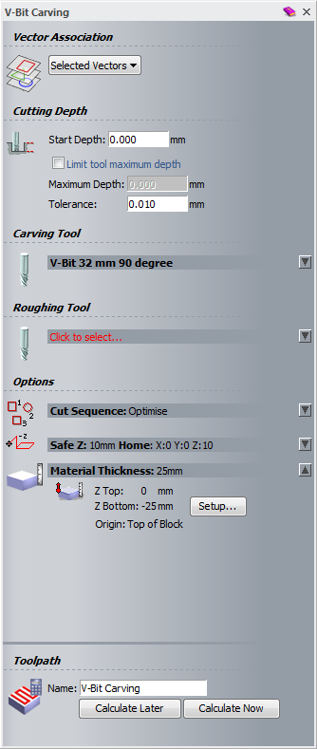
- The V-Bit Carving panel automatically opens:
- Now to define the Carving tool click on the Click to Select.. to open the Tool Database box
- Select the V-Bit 32mm 90 degree from the Metric tools- Wood or Plastic – V-Carving section and click the Select button
- Click on the arrow next to the Material Thickness section to expand the option, click on the setup, in the Material Thickness type in 25mm.
- Set the Material Z Zero to the top and the Model Position in Material to the top.

- Click OK
- Click Calculate Now to calculate the toolpath.
- Click on the X to close the toolpath panel
- To re-simulate the piece right click on the V- bit Carving toolpath in the Project panel and select Simulate Toolpath.
- ArtCAM Insignia gives you the option to change the resolution of the simulation so you can view the finished piece more clearly, ArtCAM Express has a fixed resolution.

- In ArtCAM Insignia select Simulate Toolpath (ArtCAM Express will do this automatically).
- Select Toolpaths from the Project panel to view all the toolpath creation function
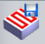
- Click on the Save Toolpaths function located in the lower half of the panel
- From the Machine output file is formatted for: box select your machine from the pulldown and select Save.
- In the File name: section type in V-Bit Pattern and select Save to save your toolpath ready to load onto your machine.

