Preperation

Saw Mill Sign
- This demonstration shows some of the 2D and 2.5D machining features available within ArtCAM Insignia. You will use several different types of machining toolpaths; Area Clearance, Bevel Carving, V-Bit Carving, Drilling, and a Profile pass with Bridges.
- Open the Saw Mill file
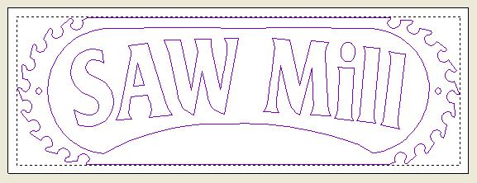

- Notice when the vectors are selected, they are purple and they are selected all at once, this means they are grouped. When a set of vectors are imported into ArtCAM, they come in as a grouped entity. For machining purposes, we want to treat the vectors separately.

- Ensure the grouped vectors are still selected and click the Ungroup vector function in the Vector Editing Toolbar

Area Clearance Toolpath

- We will create some toolpaths to clear out the background material around the letters. Since the letters will be used in a few different toolpaths as machining boundaries, we will first group the text together.
- Using the Left mouse button, drag a box around the letters to select them
- The selected text should look like this:
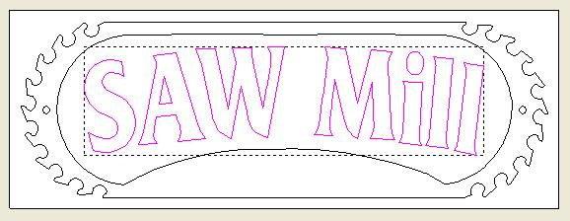

- Click the Group vector function in the Vector Editing Toolbar
- Now (make sure the text is still selected) hold down the Shift key for a multiple selection and select the vector surrounding the letters
- The selected vectors should look like this:
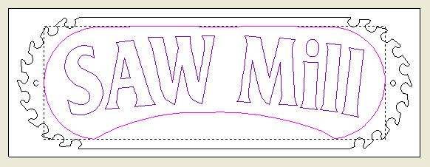

- The Area Clearance toolpath can now be generated.
On the Project panel, click on Toolpaths to show the toolpath creation icons
- Click on the Area Clearance toolpath function located in the lower half of the panel
- The 2D Area Clearance panel automatically opens:
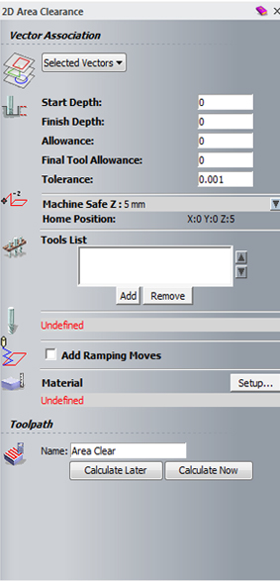

- Enter a Finish Depth of 8mm and a Tolerance of 0.01mm
- In the Machine Safe Z section, click the pull down arrow to display the hidden values
- Change the Safe Z to and Home Position Z to 10mm

- Now we can select the tools to be used. Area Clearance allows several tools to be selected for this strategy, and will machine first with the largest tool, then the next sized tool will be used only to machine areas left un-machined by the previous tool, and so on.

- Click the Add button in the Tools List section
- Select the End Mill 12mm from the Wood or Plastic - Roughing and 2D Finishing section of the database
- Repeat this procedure to select the End Mill 6mm and the End Mill 1.5mm
- There should now be three tools listed. As each one is selected, the options associated with that tool are shown below the Tools List box.
- Select the End Mill 6mm in the Tool List box
- Change the Tool Clearance Strategy from Raster to Offset as shown:
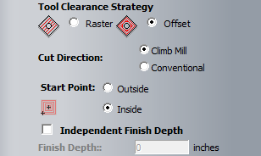
- Repeat this for the End Mill 1.5mm
- Click the Setup… button to define the material

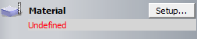
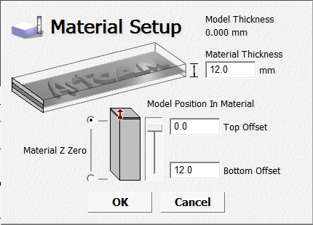

- Ensure that the Material Z Zero is set to Top of Block, and the Thickness is 12mm as shown above
- Click the Calculate Now button to generate the toolpaths
- The 2D toolpath preview appears in the 2D view.
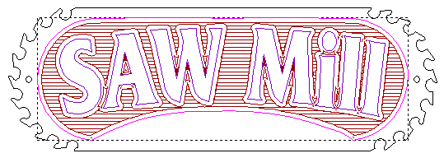
- Click on the X to close the toolpath and panel
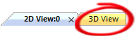
- Click on the 3D View Tab found in the top left corner to switch to the 3D view
- The toolpaths look like this:
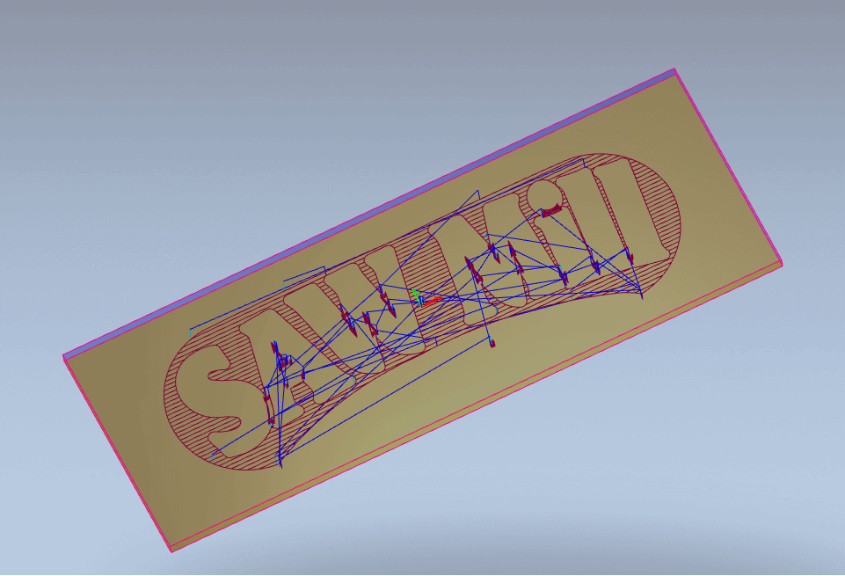
- The Project Panel looks like this:
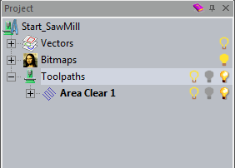

- Click the plus sign next to Area Clear to view all the associated tools
- Click on the End Mill 12mm toolpath to select it
- Right click on Simulate Toolpath
- Play through the simulation until finished
- The simulation in the 3D view looks like this:
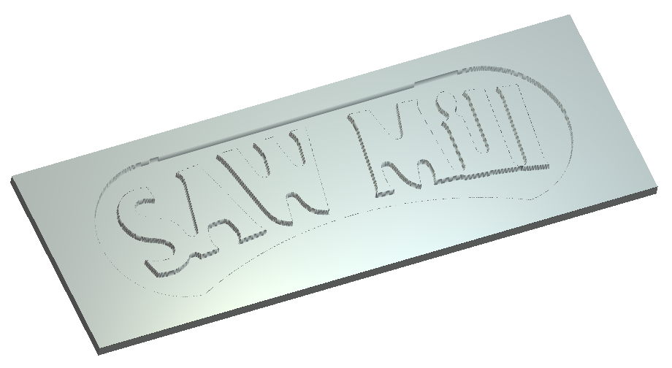
- Select the End Mill 6mm toolpath in the Project Tree
- Right click and select Simulate Toolpath
- The Simulation looks like this:
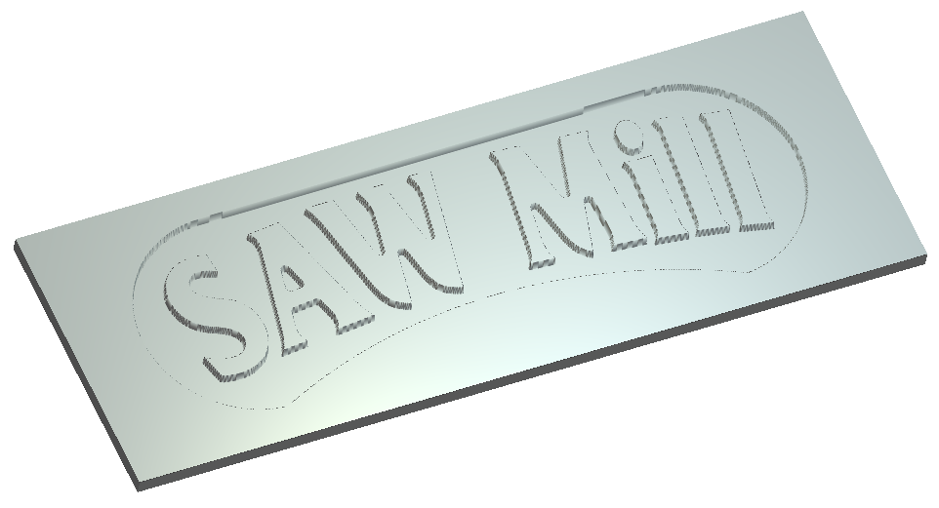

- The simulation is a mimic of the actual piece after each toolpath has been machined.
- Select the End Mill 1.5mm toolpath in the Project Tree
- Right click and select Simulate Toolpath
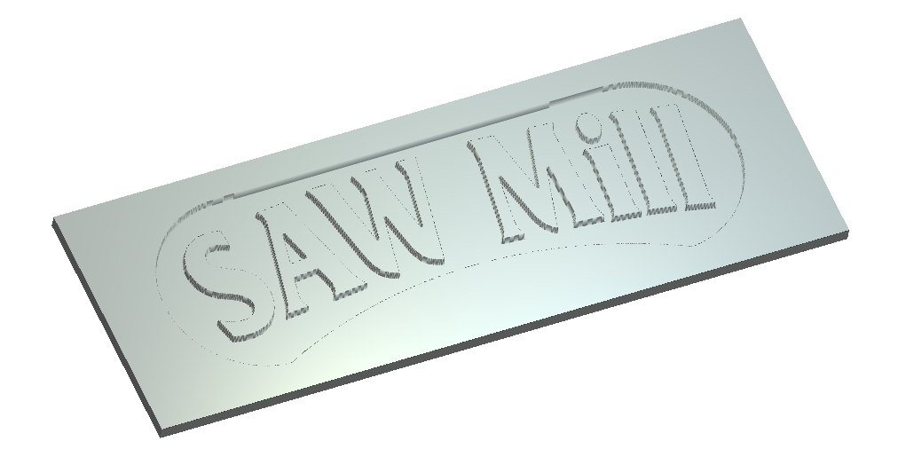

Bevel Toolpath

- Now we will generate a Bevel toolpath to create positive prismatic letters.
- Click on the 2D View Tab 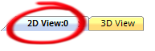
- Click the grey scratch area to de-select the vectors
- Select the grouped vector letters as shown:
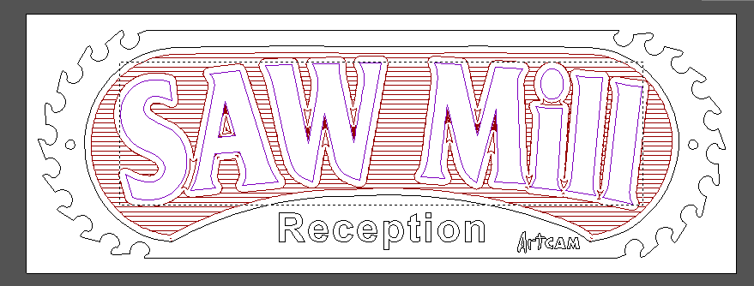

- On the Project panel, click on Toolpaths to show the toolpath creation icons
- Click on the Bevel Carving toolpath function located in the lower half of the panel
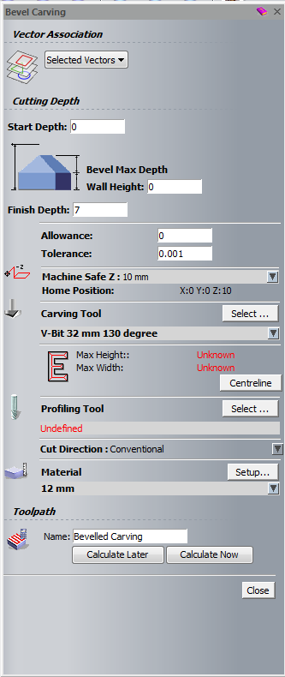
- The 3D Bevel Carving panel appears automatically:
- Enter a Finish Depth of 7mm
- We are not using a wall height, as the background is already machined and we do not need to cut the letters out, so we will leave it set to 0.
- Now to define the Carving Tool, click the Select... button in the Carving Tool section
- The Tool Database appears, select the V-Bit 32mm 130 degree from the Wood or Plastic – V-Carving section and click the Select button
- The V-bit tool should appear on the page.
- Since we are not creating a Wall Height, we will not select a Profiling Tool. The Profiling Tool would be used to cut the profile of the vector leaving a straight edge.
- Click the Calculate Now button to generate the toolpath
- Click on the X to close the toolpath and panel

- The Preview Vectors appear in the 2D view, and look like this:
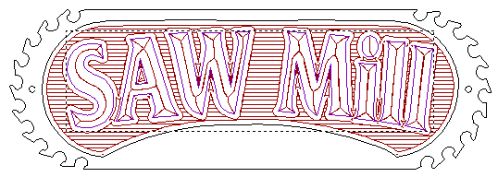
- Click on the 3D View Tab
- The Bevel Toolpath looks like this:
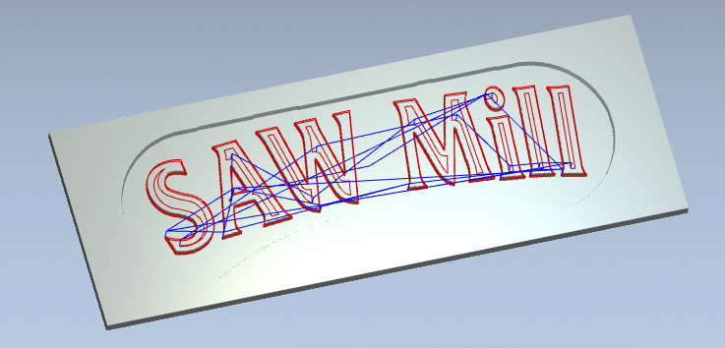
- Right click on the Bevel toolpath and select Simulate toolpath
- The Simulation looks like this:
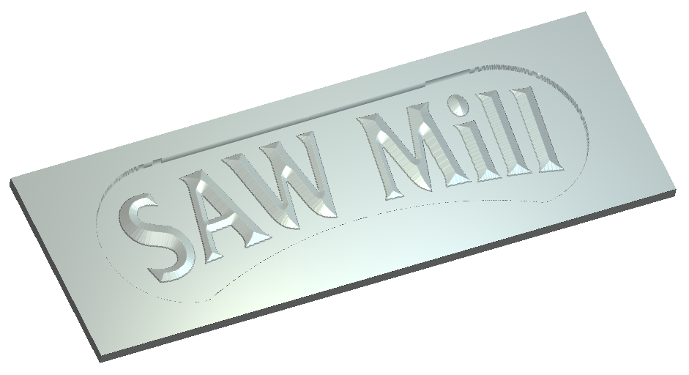

V-Bit Carving

- In this section, we will engrave some text. First we need to create the text.

- Click on the 2D View Tab to go back to the 2D view

Click the Create Vector Text button in the Design Tools Toolbar
- The Text Tool function appears in the Tool Settings Panel:
- Set the Style of text to be Bold, Arial, with a Size of 25mm and Character Spacing at 20%,
- Now click the mouse button in the 2D View and type the text ‘Reception’
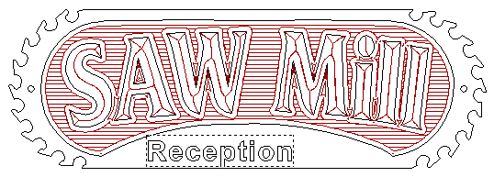

- Right click to finish and exit text creation
- We need to make sure that the text is centered in the sign.
- Select the text, if not already selected, and then Shift-select the outer profile as shown. (The text MUST be selected first.)

- Click the Centre Horizontally button on the Vector Editing Toolbar
- Click anywhere in the 2D View to de-select the vectors
- Then select the vector text only
- Now use the Up or Down arrow cursor keys on the keyboard to move the letters approximately into position as shown
- The finished Reception text looks like this:
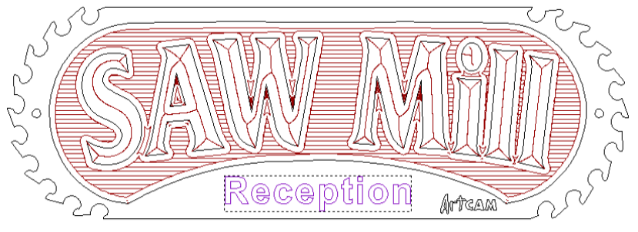
- We now apply a toolpath to the text using V-Bit carving.
- Ensure the Reception text is still selected
- Select Toolpaths from the Project Tree to view all the toolpath creation icons
- Click on the V - Bit Carving toolpath function located in the lower half of the panel
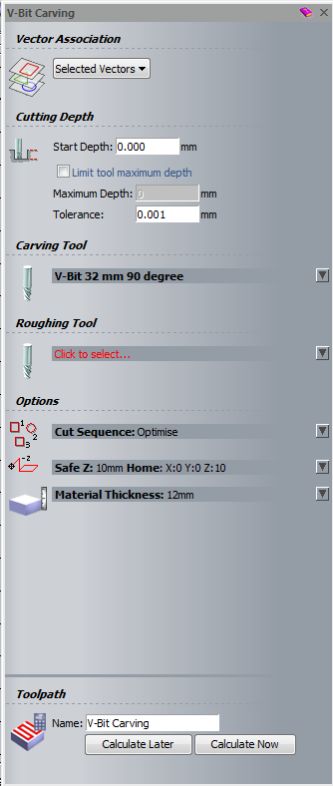
- The V-Bit Carving panel appears automatically:
- Select the Click to Select... to select the Carving Tool
- Select the V-Bit 32mm 90 degree tool from the list, and click the Select button to select it
- Next click the Calculate Now button to calculate the Toolpath
- ArtCAM automatically generates the centrelines of the vectors and calculates the toolpath.
- The Preview Vectors appear in the 2D View and look like this:

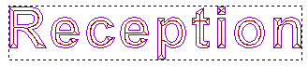
- Click on the X to close the toolpath panel
- Click on the 3D View Tab
- The toolpath looks like this:
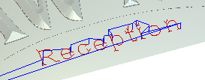
- Right click on the V – Bit Carving Toolpath in the Project Tree and select Simulate Toolpath
- The Simulation looks like this:
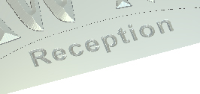

Drilling

- Now we can drill the holes needed to mount the sign to the wall.
- Click on the 2D View Tab
- First, select the two hole positions marked in the 2D View using the left mouse button as shown. (Select one, and then Shift-select the other)

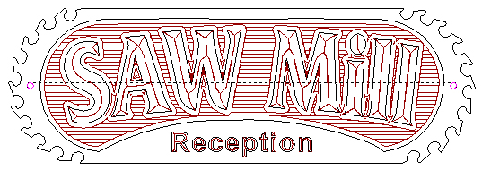

- Select Toolpaths from the Project Tree to view all the toolpath creation icons
- Click on the Drilling toolpath function located in the lower half of the panel
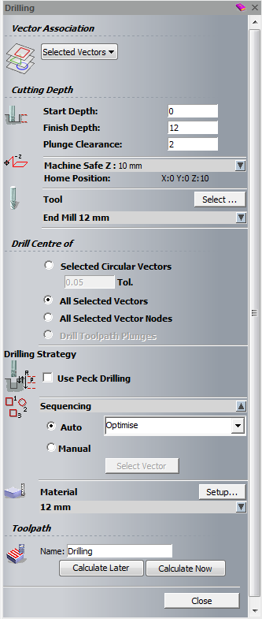
- The Drilling function appears automatically:
- Click the Select... button to select a Tool
- Select the End Mill 12 mm by double clicking it
- (Note as we stretched the vectors un-proportionally, the drill holes are no longer true circles so we will use the all selected vectors option instead of Circular Vectors.) has to be removed
- In the Drill Centre of... section of the Drilling Page, select the option All Selected Vectors
- Click the Calculate Now button to generate the toolpath

- The Preview Vectors look like this:

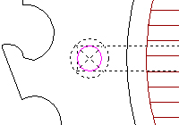

- Click on the X to close the toolpath panel
- Click on the 3D View Tab
- The Drilling Toolpath looks like this:
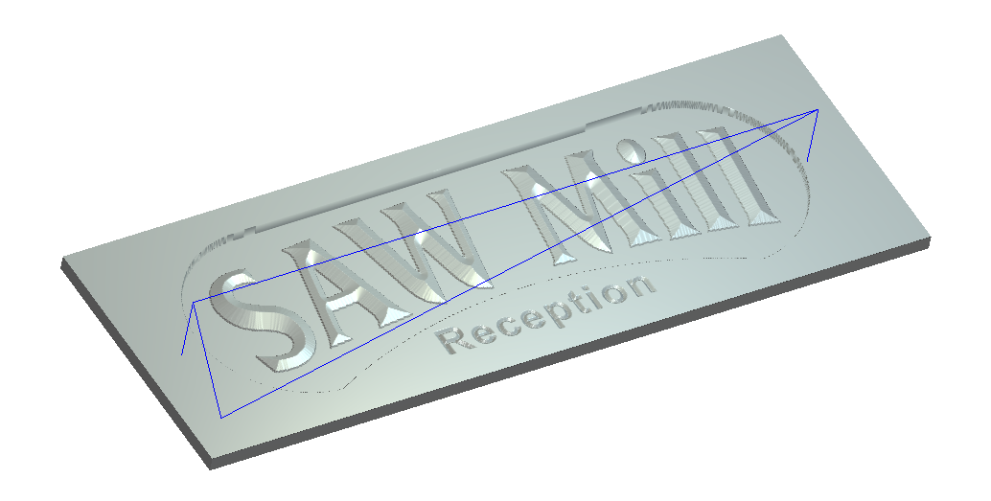
- Right click on the Toolpath in the Project Tree and select Simulate Toolpath
- The simulation looks like this:
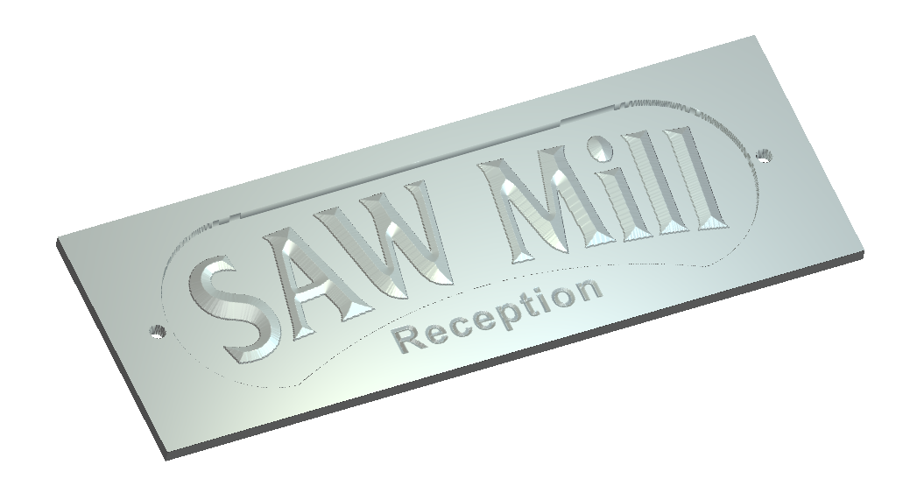

Profile Toolpath

- We are now ready to cut out the sign by profiling around the outermost vector.
- Click on the 2D View Tab
- Select the outermost vector in the 2D View as shown
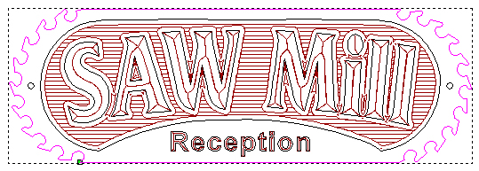
- Select Toolpaths from the Project Tree to view all the toolpath creation icon
- Click on the Profile toolpath function located in the lower half of the panel
- The Profiling function appears automatically:
- Change the profile option to Outside
- The Finish Depth is 12mm
- Click the Click to Select... button to select the Profiling Tool
- Double click the End Mill 6mm to select it
- Change the Stepdown to 12mm by using the pull arrow to access the tool parameters
- Check the option Add Lead In/Out Moves in the Profiling Panel as shown

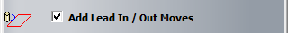
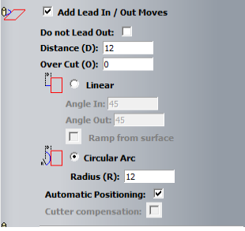
- The Panel is expanded to show the options for Leads:
- Select the option Circular Arc, and enter a Distance of 12mm and a Radius of 12mm
- Click Calculate Now to generate the Toolpath

- The Preview Vectors look like this:
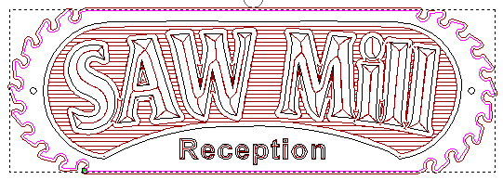
- Notice the Circular Lead:
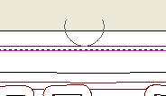
- This is automatically positioned in the middle of the longest span, unless the Automatic Positioning option is switched off, in which case the Start Point of the vector is used as the position. This allows the user to define the position manually if required.
- Click on the X to close the toolpath and panel
- Click on the 3D View Tab

- The Profile Toolpath looks like this:

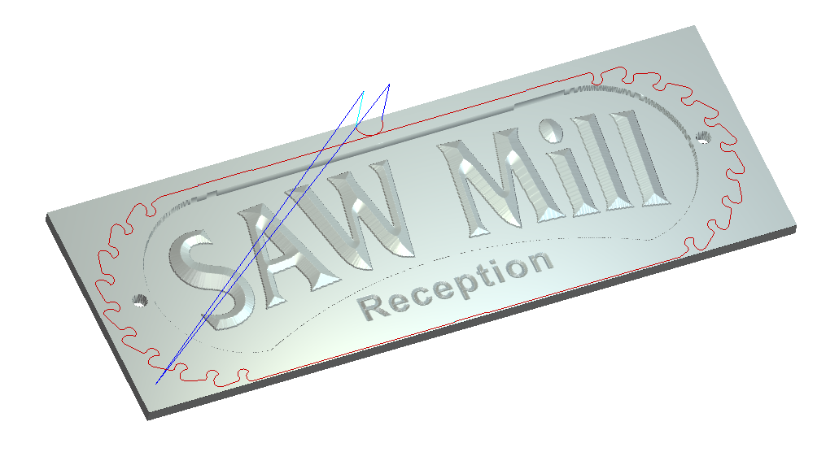
- Before we simulate this toolpath, we will demonstrate Bridging.
- Click on the 2D View Tab
- In the project Tree, click on the plus sign next to the calculated Profile toolpath
- Select Profile toolpath tool End Mill 6mm
- Click the Profile Options function
- Choose Bridges as the option
- The Bridging panel appears:

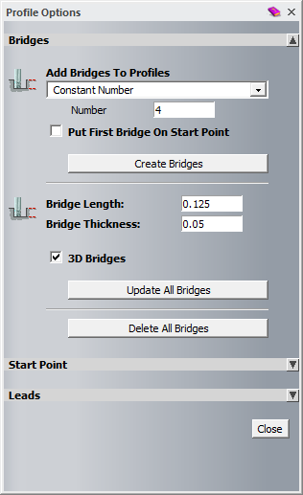

- Enter a Bridge Length of 12mm and a Bridge Thickness of 1mm
- In the Add Bridges to Profiles section, enter a Constant Number of 4
- Check the 3D Bridges option to create a 3D bridge
- Click the Create Bridges button to add the Bridges to the Toolpath
- The Profile Toolpath in the 2D View now looks like this:

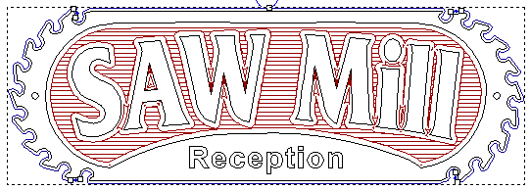

- We will now move the bridges to more sensible positions which will be easier to remove it.
- Move the mouse over the centre of the top-left bridge, so that the cursor changes to a circle with a cross going through it as shown (Zoom in if necessary using the wheel on the mouse)
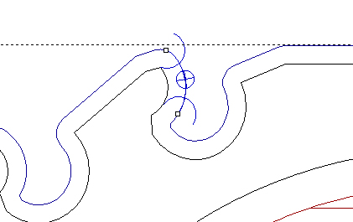

- Hold the Left mouse button down, and drag the Bridge to a more sensible position as shown:
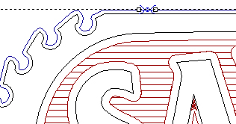

- Now move the other bridges in the same way so that they are in positions as shown:

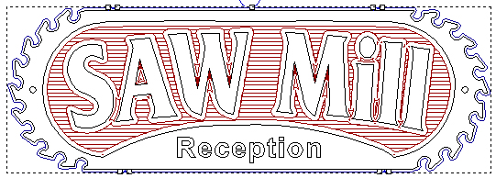

- Zoom into the top-left bridge using the wheel on the mouse
- You can remove the bridge by double clicking on it in the centre of the bridge
- Now add the Bridge back in by double clicking the Profile Toolpath
- Move the cursor over one end of the Bridge, and using the Left mouse button, drag the end to extend the Bridge as shown:
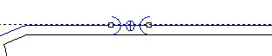
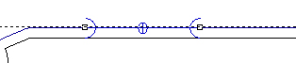

- When editing the Bridges, the 3D Profile Toolpath is automatically updated interactively.

- To see this, tile the 2D View and the 3D View using the Window pull down Tile Horizontally menu option
- Now move or edit the Bridge in the 2D View to show that the 3D View automatically updates
- Click the Close button to exit the Bridging page
- We can now simulate the Profile Toolpath.
- Maximize the 3D view
- Right click on the Profile Toolpath in the Project Tree and select Simulate toolpath
- The Simulation looks like this:
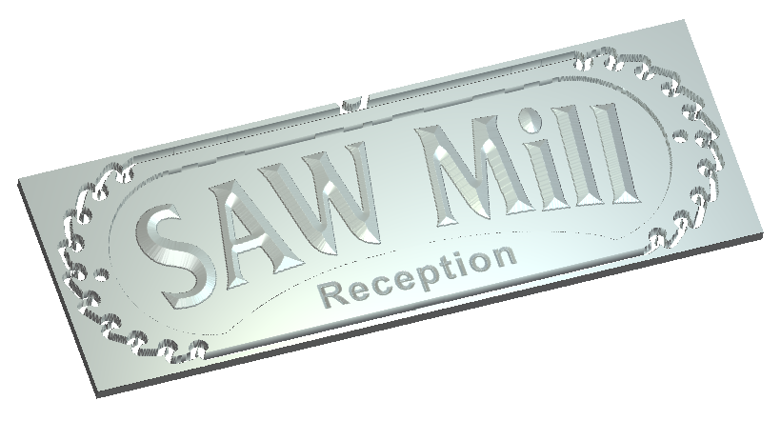
- Click on the 3D Graphics Options icon on the 3D View toolbar and select Simulation Rendering. Choose Oak as the Material option to see what the toolpath will look like once cut into the material
- Click on the X to close the 3D Graphics Options panel.
- Zoom in to view one of the bridges using the Right mouse button as shown:
