Run PYG_DLL_Patcher_x64.exe with administrator rights

If the language its not English open PYG_Dll_Patcher_x64.ini and change “CurrentLanguage=2”

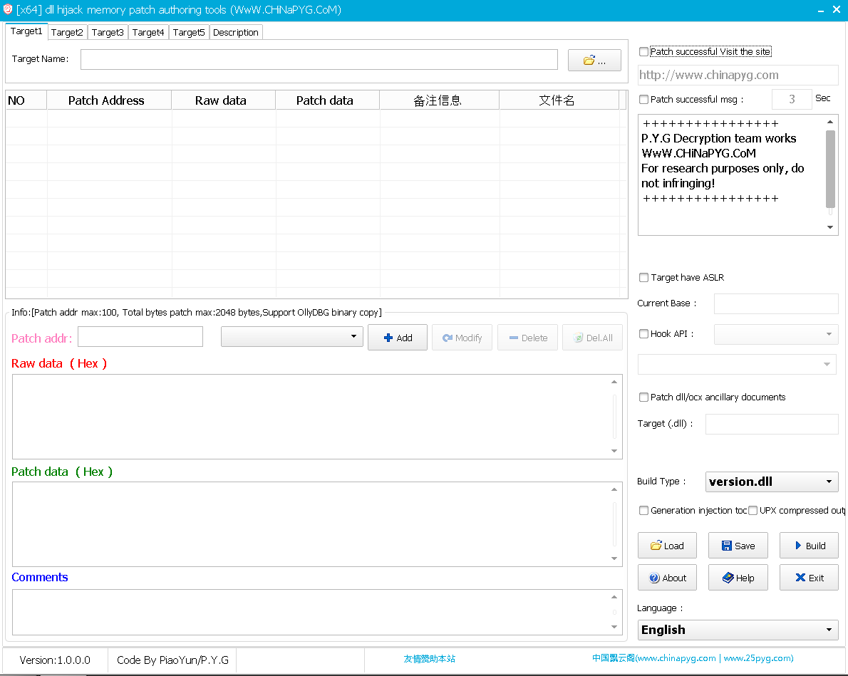

Deselect the two “Patch….” Options to disable message and web page

Click “Load”

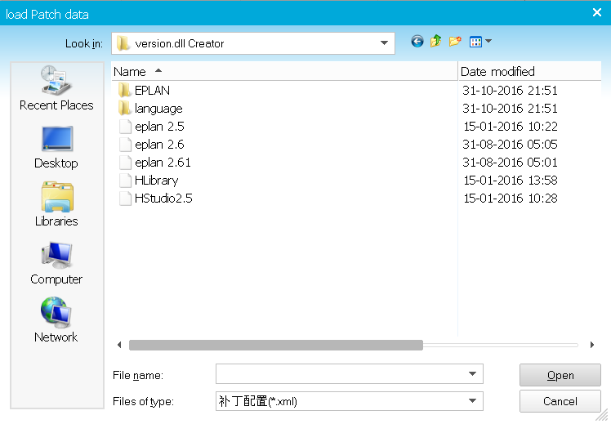

Select You eplan version .xml file

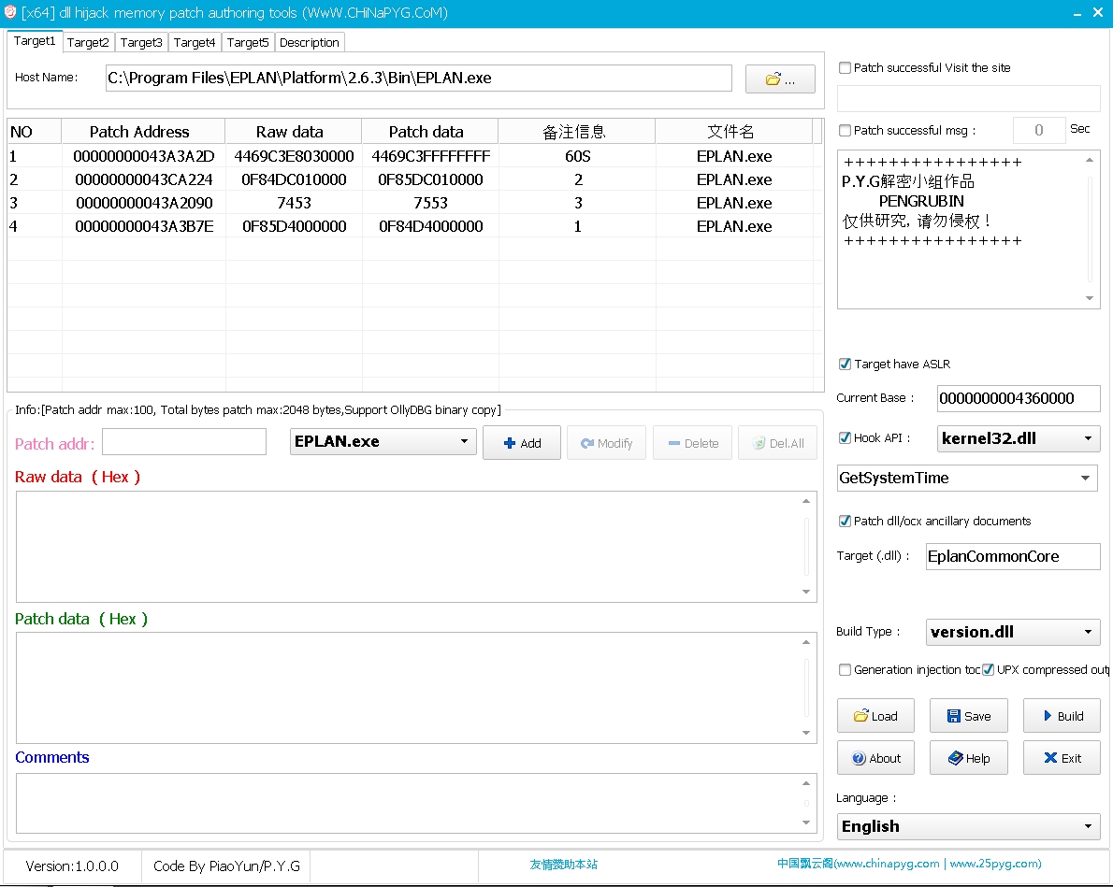

Click “Build”

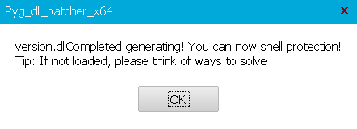

Click “OK”

The version.dll Output will be on the folder “…version.dll Creator\EPLAN”